EXPERIMENT 3

NAME: GRACE JEYARANI P ROLLNO: 240701158
1.COMMAND LINE INTERFACE:
import sys
filename = sys.argv[1]
with open(filename, 'w') as f:
pass
print(f"File '{filename}' created successfully!")

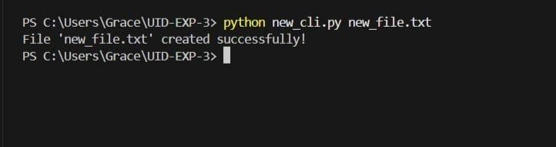
2.GRAPHICAL USER INTERFACE:
import tkinter as tk
from tkinter import messagebox
import os
def create_file():
filename = entry.get()
if filename == "":
messagebox.showerror("Error", "Please enter a filename!")
return
with open(filename, 'w') as f:
pass
messagebox.showinfo("Success", f"File '{filename}' created!")
entry.delete(0, tk.END)
root = tk.Tk()
root.title("Empty File Creator")
root.geometry("300x150")
label = tk.Label(root, text="Enter filename:", font=("Arial", 12))
label.pack(pady=10)
entry = tk.Entry(root, width=30, font=("Arial", 12))
entry.pack(pady=5)
button = tk.Button(root, text="Create Empty File", command=create_file,
bg="blue", fg="white", font=("Arial", 11))
button.pack(pady=10)
root.mainloop()
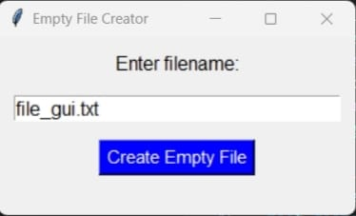
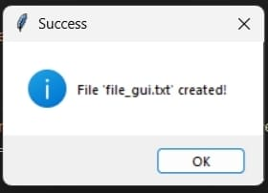

3.VOICE USER INTERFACE:
import speech_recognition as sr
import pyttsx3
import os
engine = pyttsx3.init()
r = sr.Recognizer()
def speak(text):
engine.say(text)
engine.runAndWait()
speak("Say the filename")
with sr.Microphone() as source:
print("Listening...")
audio = r.listen(source)
try:
filename = r.recognize_google(audio).lower()
print("Filename:", filename)
filename = filename + ".txt"
open(filename, 'w').close()
speak(f"Created {filename}")
print(f"✅ File created: {filename}")
except:
speak("Sorry, try again")
